

**Broker View Feature – View CE Marketplace activity for your office**

Once you have logged in, click on **Office CE Credits** from the menu on the top of the page:



After clicking on **Office CE Credits**, you will enter your complete 10-digit Michigan Employer License Number, or optional 9-digit NRDS Office ID to view office CE:

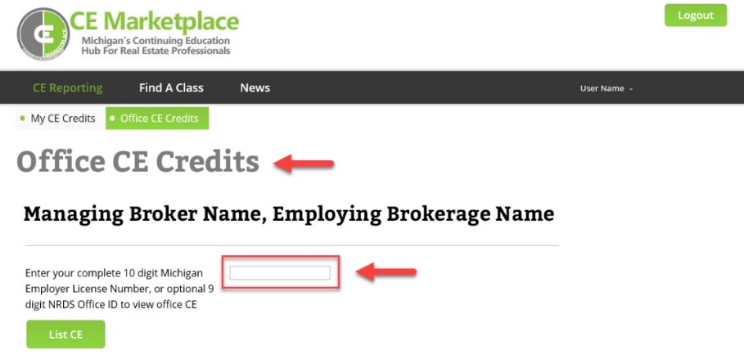

By clicking on the individual Office Name, you can view a list of agents associated with that location.

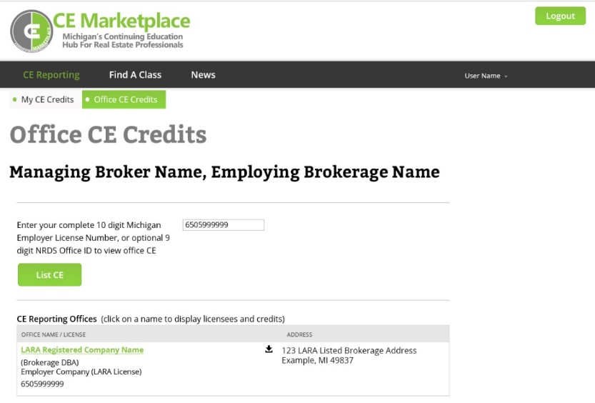

Agents with an * next to their name have logged in and are active users of CE Marketplace. You have the ability to click on the agents’ names to view their CE History, but you cannot make any changes to their records. You may also download copies of the reports in Microsoft Excel format by clicking on the icons or link next to the office(s).

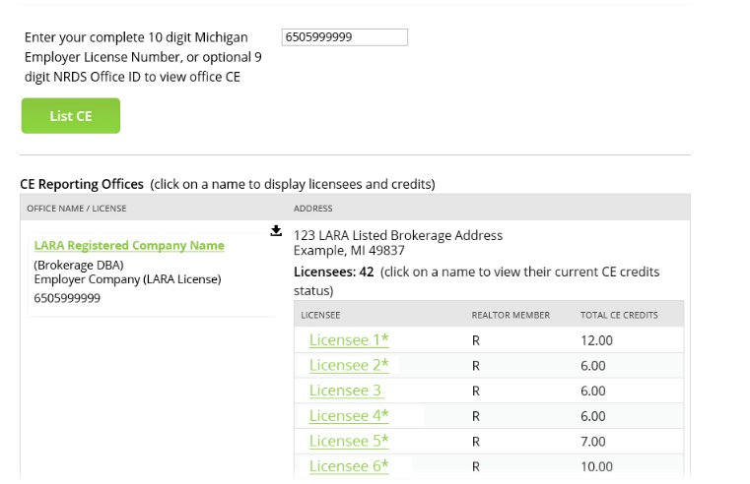

Have any questions or comments about your Office CE Credits report? We’re here to help. We can be contacted via telephone at (844) 642-6633, Monday through Friday, from 9 am to 4 pm or via email at tracking@cemarketplace.net.